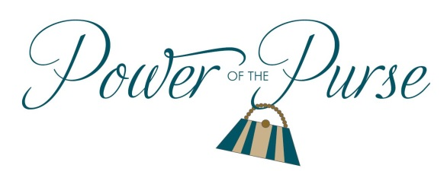
Women United
United Way of the Lowcountry
2019 Woman of the Year
United Way of the Lowcountry’s Women United is currently accepting nominations for the 2019 Woman of the Year. Please see the requirements for nomination below.

- Nominee must be female.
- Nominee must be a resident of Beaufort or Jasper County.
- Nominee must have made a powerful impact on the local community through their volunteer efforts and served as a role model for inspiration and achievement of other women.

Nomination forms can be downloaded on the United Way of the Lowcountry website at www.uwlowcountry.org. Completed forms should be emailed to jdaileyvergara@uwlowcountry.org or mailed to the address below. Nominations should be submitted no later than Friday, February 22 by 5:00 pm.

United Way of the Lowcountry
Attn: Jaime Dailey-Vergara
P.O. Box 202
Beaufort, SC 29901

Please direct all questions to Jaime Dailey-Vergara at
jdaileyvergara@uwlowcountry.org or 843-982-3040.
The Women United Steering Committee will review the nominations and announce the winner at the Power of the Purse event on March 14, 2019 at the Dataw Island Clubhouse beginning at 6:00 p.m. The finalists will be announced prior to the event to ensure their attendance. Tickets for the Power of the Purse are available for purchase at www.uwlowcountry.org.

