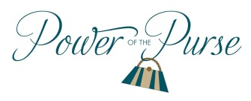
Women United
United Way of the Lowcountry
2019 Woman of the Year
Nominee Contact Information:
Nominee Name
Nominee Address
City
Postal Code
Nominee Phone Number
Nominee Email Address
Nominator Information:
Name
Address
City
Postal Code
Phone Number
Email Address
Tell us about the Nominee
- Provide a brief personal description and/or some unique qualities of your nominee in regards to why they are being nominated for Woman of the Year.
- How has the nominee made an important contribution or lasting impact in Beaufort or Jasper County through their volunteer work?
- How does the nominee’s involvement inspire those around her?
- What qualities make the nominee someone to admire?
Submit Nominations to Jaime Dailey-Vergara at jdaileyvergara@uwlowcountry.org.
Nominations Due: No later than Friday, February 22 by 5:00 pm. Please contact Jaime Dailey-Vergara at 843.982.3040 or jdaileyvergara@uwlowcountry.org with any questions.

