2021 United Way of the Lowcountry Community Champion Follow-up Email: Together, we can make a lasting impact.
Dear Neighbor,
In these unprecedented times, we come together because we know change doesn’t happen alone.

(We/I) would like to thank you for taking the time to learn more about United Way of the Lowcountry (UWLC) and the vital role it plays in our community. It can be a challenging time for many in our community struggling to put food on the table and to keep the lights on.

(We are/I am) grateful for our neighbors here in (neighborhood name) who have joined (me/us) in support of UWLC, which serves those in need throughout Beaufort and Jasper counties. So far, we have raised (dollar amount) this year here in (neighborhood name) for this worthy cause. These dollars will help meet the immediate needs of our neighbors and build a stronger community by supporting UWLC's internal programs like the HELPLINE, which offers health and human services information, referral, advocacy and support to help callers find the assistance they need. Last year, UWLC was able to:
- Provide 5,633 referrals for assistance to our neighbors through our HELPLINE
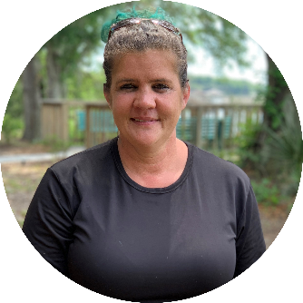
- Offer direct assistance to more than 600 community members who were unable to receive support elsewhere
Meet Wanda
Like so many of our neighbors, Wanda and her family moved to the Lowcountry looking for a fresh start. However, soon after relocating to Beaufort, Wanda was diagnosed with a serious health issue that made it impossible for her to continue to help support her family. Faced with mounting medical bills and the possible loss of their home during a pandemic, HELPLINE was able to provide the funds and referrals needed to help her family find stable housing. Watch Wanda tell her story in a video at that bottom of this email.
As you know, the need is great and United Way needs our support this year like never before. It takes all of us working together to make a lasting impact and we hope you will consider joining us! Your investment in UWLC supports LOCAL programs like the HELPLINE that are vital to making Beaufort and Jasper counties a better place to live and work.
(Neighborhood name) can help make a lasting impact in our community and help our neighbors, like Wanda, when they need it the most. Thank you again for your consideration and please feel free to contact (me/us) with any questions.

Kind Regards,

Champion Names
Phone Numbers
LIVE HERE. GIVE HERE. HELP HERE.

