2021 United Way of the Lowcountry Community Champion Follow-up Letter
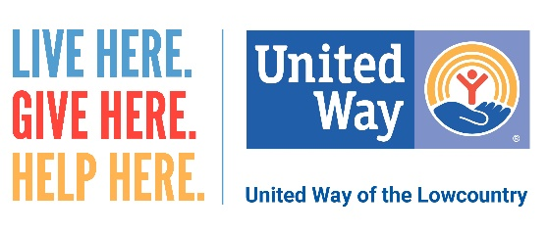
Dear (names),

As you may know, we are in unprecedented times and the need in our community is greater than it has ever been in the past. Throughout the pandemic, the United Way of the Lowcountry (UWLC) has stepped up to help support partner agencies as well as our neighbors throughout Beaufort and Jasper counties who continue to struggle to make ends meet.

(We/I) support United Way because (… of the holistic approach it takes in addressing the critical needs facing our community, focusing on Basic Needs, Education, Health and Economic Mobility. The pandemic has impacted each of these four pillars, creating an even greater need here in the Lowcountry. Many of our neighbors, who have never needed assistance in the past, are reaching out for a helping hand to put food on the table and keep a roof over their heads. Local students continue to face challenges that make UWLC’s efforts in Early Grade Reading even more critical.)

(We/I) encourage you to take a look at the enclosed Palmetto Society book to see the many ways UWLC is making a difference in our community through supporting local agencies and internal programs like the HELPLINE and Read Indeed. Your investment is important in supporting:

- 38 programs in 23 local nonprofit agencies, all vetted by community members through site visits as well as financial and program reviews.
- HELPLINE, which offers health and human services information, referral, advocacy and support to help callers find the assistance they need. Last year, UWLC provided 5,633 referrals for assistance and offered direct assistance to more than 600 community members who were unable to receive support elsewhere.
- Early Grade Reading Initiative, Read Indeed. A child learns to read until the fourth grade. After that, they read to learn. With the help volunteers and AmeriCorps members, the UWLC’s Early Grade Reading Initiative works with Pre-K through third graders to help ensure children are prepared for success in school.

(We/I) hope you will consider investing in UWLC. With our help, this year when it is needed the most. Thank you for taking your time, and please feel free to reach out to me with any questions.

Your Neighbor(s),

Champion Names
Phone Numbers

LIVE HERE. GIVE HERE. HELP HERE.

