2021 United Way of the Lowcountry Workplace Campaign Email Templates

FINAL EMAIL
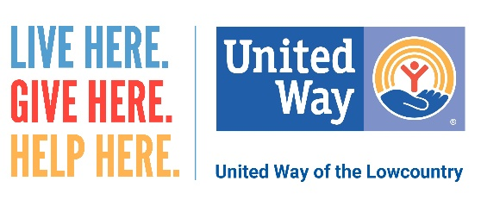
Dear (Company Name) Family,
Our United Way of the Lowcountry campaign ends today! If you have not already donated, please consider doing so now.
Your investment will create benefits that ripple throughout our community. Change doesn’t happen alone.
Please consider joining in these efforts to support a community that provides residents in Beaufort and Jasper counties the opportunity to not only survive, but also to thrive. Today is the day to choose to LIVE UNITED.
Click here [insert personalized giving link] to make your online donation. Your gift may be made through payroll deduction, credit card or cash/check.
LIVE HERE. GIVE HERE. HELP HERE.

