2021 United Way of the Lowcountry Workplace Campaign Email Templates

KICKOFF EMAIL
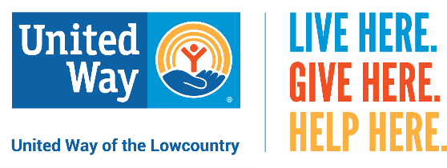
Dear (Company Name) Family,
We are excited to kick off our 2021 United Way of the Lowcountry Workplace Campaign here at (Company Name) and hope you will consider being a part of it this year!
United Way of the Lowcountry (UWLC) has been serving Beaufort and Jasper counties for decades and continues to make a big impact. This past year, 149, 641 local people benefited from United Way's Community Impact funded programs and direct services thanks to people like you.
UWLC works to address the immediate needs of our neighbors through funded partner agencies you may know and direct services like the HELPLINE. At the same time, UWLC continues to work to create lasting change in our area through Community Impact by focusing on Basic Needs, Education, Healthy and Economic Mobility.
Last year, through your support, UWLC was able to:
- Fund 38 local programs focusing on Education, Health, Basic Needs and Economic Mobility
- Distribute more than 20,000 books to students in our community through collaborations with both Jasper County and Beaufort County school districts
- Provide 5,633 referrals for assistance to our neighbors through our HELPLINE
- Offer direct assistance to more than 600 community members who were unable to receive support elsewhere
Please watch the following video to see how our local United Way is making a difference in our community – https://youtu.be/Rm5dYRUOVZg
I hope you will consider giving to United Way this year by clicking here [insert personalized giving link] to make your online donation by [insert deadline]. It’s the most effective and efficient way to create lasting change in our community. Your gift may be made through payroll deduction, credit card or cash/check. Please remember that every dollar makes an impact.
LIVE HERE. GIVE HERE. HELP HERE.

