2021 United Way of the Lowcountry Workplace Campaign Email Templates

REMINDER EMAIL #1
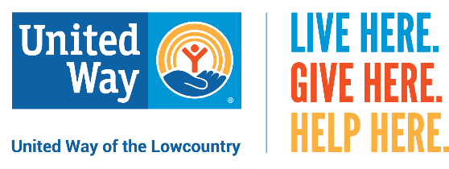
Dear (Company Name) Family,
In these unprecedented times, we come together because we know change doesn’t happen alone.
Last year, United Way of the Lowcountry (UWLC) saw our neighbors struggle like never before. Families that had never asked for help needed assistance to pay power and water bills, buy food and provide for their children. So today, I’m asking you to HELP United Way to ensure every member of our community can thrive.
UWLC’s HELPLINE – 843.524.4357 – offers health and human services information, referral, advocacy and support to help callers find the assistance they need to address the everyday challenges of living as well as those that develop during times of disaster and other community emergencies. Last year, through your support, UWLC was able to:
- Provide 5,633 referrals for assistance to our neighbors through our HELPLINE
- Offer direct assistance to more than 600 community members who were unable to receive support elsewhere
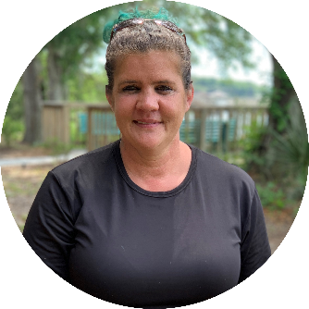
Like so many of our neighbors, Wanda and her family moved to the Lowcountry looking for a fresh start. However, soon after relocating to Beaufort, Wanda was diagnosed with a serious health issue that made it impossible for her to continue to help support her family. Faced with mounting medical bills and the possible loss of their home during a pandemic, HELPLINE was able to provide the funds and referrals needed to help her family find stable housing. Click here to watch Wanda’s story.
Your investment in UWLC supports LOCAL programs like the HELPLINE that are vital to making Beaufort and Jasper counties a better place to live and work.
I hope you will consider giving to United Way this year by clicking here [insert personalized giving link] to make your online donation by [insert deadline]. It’s the most effective and efficient way to create lasting change in our community. Your gift may be made through payroll deduction, credit card or cash/check. Please remember that every dollar makes an impact.
LIVE HERE. GIVE HERE. HELP HERE.

