2021 United Way of the Lowcountry Workplace Campaign Email Templates

REMINDER EMAIL #2
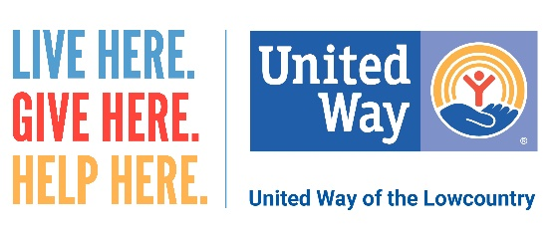
Dear (Company Name) Family,
Did you know that a child learns to read until fourth grade? After that, they read to learn.
Though your support, United Way of the Lowcountry is making an impact on education through its Early Grade Reading Initiative, Read Indeed!
Read Indeed! offers one-on-one, in-person and virtual tutoring for Pre-K through third grade students in Beaufort and Jasper counties. Despite challenges created by the pandemic, Read Indeed continues to serve 10 locations throughout the Lowcountry.
To help minimize the loss of learning that occurs when young minds sit idle during the summer, UWLC also partners with Pi Phi, the Public Library Foundation of Beaufort County/ Beaufort County Library System and the Beaufort County School District to provide 10,000 free picture and chapter books to children of all ages throughout our community! As an added treat, volunteers – including Ron and Natalie Daise from “Gullah Gullah Island!” – record videos of themselves reading aloud from one of the books. Click here to watch Ron and Natalie Daise.
Your investment in UWLC supports LOCAL programs like Read Indeed! that are vital to making Beaufort and Jasper counties a better place to live and work.
I hope you will consider giving to United Way this year by clicking here [insert personalized giving link] to make your online donation by [insert deadline]. It’s the most effective and efficient way to create lasting change in our community. Your gift may be made through payroll deduction, credit card or cash/check. Please remember that every dollar makes an impact.
LIVE HERE. GIVE HERE. HELP HERE.

