2021 United Way of the Lowcountry Community Champion Thank You Email/Letter: We did it!
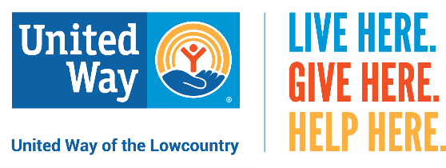

Dear (personalized),
Thank you!
Together, we raised more than ($$$) on behalf of United Way of the Lowcountry.
Your donation to United Way brings hope and opportunity to the lives of so many by providing for basic needs, helping adults find family-sustaining jobs and affordable housing, and creating environments that nurture positive development of our children.
Because United Way actively manages and evaluates the effectiveness of its community partner agencies, you can be sure that your gift will be invested in most successful and cost-effective, human-service programs in Beaufort and Jasper counties.
Your generosity is helping make the Lowcountry a better place to live.

Kind Regards,
Champion Names

LIVE HERE. GIVE HERE. HELP HERE.

