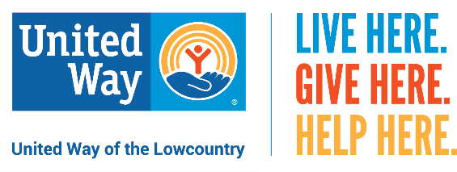

Community Champions Program:
Steps to Help Create a Successful Campaign

THANK YOU for taking on the role of a Community Champion! We realize that every neighborhood is unique so we're here to help you personalize your campaign, using the tools available in our online Community Champions Toolkit. Below you’ll find some helpful steps to create a successful neighborhood campaign.

Pre-Campaign Planning
- Take a moment to collect the names, emails and addresses of the neighbors you’d like to include in your campaign. If possible, please share the information with us in a Word document or an Excel spreadsheet.

- Let us know if you’re comfortable holding a neighborhood event. If so, we can create an online invitation, coordinate RSVPs and provide United Way and partner agency speakers.

- Create a calendar of how you’d like to reach out to your neighbors. We’ve found that successful neighborhood campaigns use a combination of at least three “touchpoints” (emails and/or letters) over a two-to-three-month period. We can help you with your schedule.

- Review the email and letter templates found online in your Community Champions Toolkit.
Feel free to personalize the templates provided or write your own. Don’t worry – we’ll work with you through the writing process.

- Approve your neighborhood’s personalized online landing page and giving link that we’ll create on our website.

Campaign Kick-off
- Once we’ve sent your first email or letter on your behalf, it’s time to get social! Let your family and friends know why you support United Way of the Lowcountry using the social media templates, videos and hashtags found in your Community Champions Toolkit.
- We’ll keep you updated (as often as you’d like) on any gifts received from your neighbors throughout the campaign.

Campaign Wrap-up
- Now that your neighborhood campaign is completed, we’d love to meet with you to debrief and identify any opportunities for improving our Community Champions program.

