Community Impact Training

Guide for Agencies - Application

Our site URL is: [https://uwlowcountrygrants.communityforce.com](https://uwlowcountrygrants.communityforce.com/)

(Go ahead and bookmark it ☺)

Login

Click on my applications

Select which application you would like to work on

Now, when you go to the dashboard, there will be a new icon “Start Application”. Click on it.

You will get this message, click on the “click Here”

You will be brought to your application dashboard. You will now see the new icons for the application phase and can begin working on your application.

Now, when you go back to your “My Applications” tab, you will see your Application

Please ONLY click on the “Start Application” button once or you will open several versions of the same application. After you have clicked on the “start Application” button, you will access that open application by going to your “My Application” tab.

**Text boxes:** There is no spellcheck feature in the text box, therefore, it is our recommendation to type your information into Word, use the spellcheck feature in Word, and then cut and paste into the text box.

Each text box has a word limit, meaning you need to be sure to add your information, while staying under the word count. You can monitor your word count by looking in the bottom left corner of the text box.

You can easily toggle the box to make it bigger by clicking the arrow in the bottom left coner under the WORD count, holding it, and dragging.

When uploading documents, other than the provided templates that are in excel format, all uploaded documents must be in PDF format. Keep in mind, how you see the documents is how the reviewers see them. Please be sure to look at each document in VIEW mode so you can see exactly what it will look like and to ensure it is the correct size and format (not too big or too small and can be easily read).

**Final Review and Submit:**

Since there could be many different staff assisting with the application, and since providing the wrong documentation could prevent you from receiving a site visit, after all questions are answered and attachments included, the Executive Director and the Board Chair are required to review all material to ensure accuracy and quality. Once the statements and electronic signatures have been provided, and all progress bars read 100%, then click on the “Final Review and Submit” button located in the upper right. The application is NOT officially submitted until this process has been completed.

If you click on the Red “Final Review and Submit” button before you have answered all questions and uploaded all attachments, you will receive this error message:

Once the final review and submit button has been clicked, the below dialog box appears: This is informing you that once this portion of the application process has been submitted, no updates to the information will be allowed.

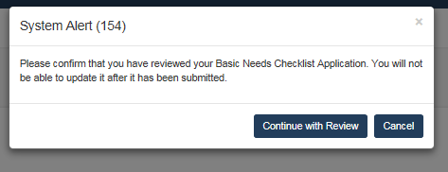

Click “Continue with review” and you will see this screen. Here you have the option to review the application in the window or print a copy to review in hardcopy. **PRINT A HARDCOPY OF THIS APPLICATION FOR YOUR AGENCY’S INTERNAL FILES**

Once the FINAL, FINAL review (☺) is completed you will be required to check the box on the top of the form and then click submit.

**You have NOW successfully submitted your application!**

Additional Features:

If you want to 1) Add Collaborator 2) Preview a copy of your application or 3) Import responses from existing applications, click on the “Choose Action” button

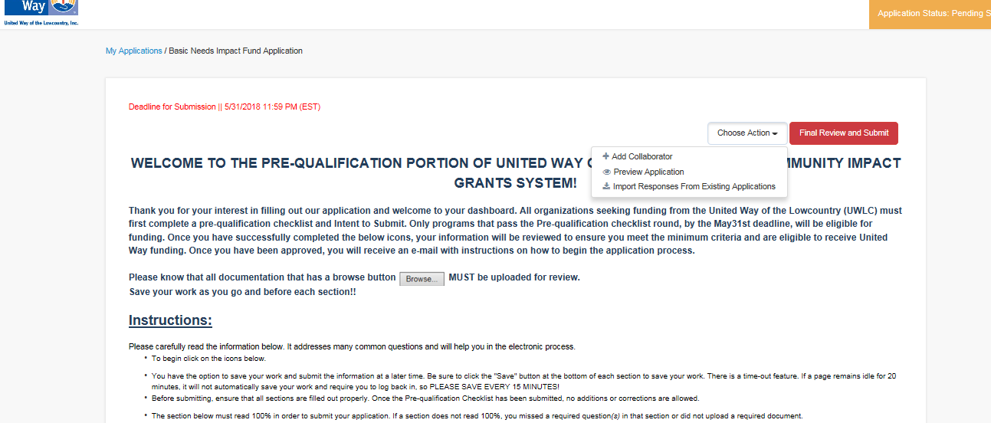

1. Preview Application

If you want to preview application, click on “Choose Action” button, then preview application

A clean copy of your application and answers will be viewable. Click on the printer icon to print.

