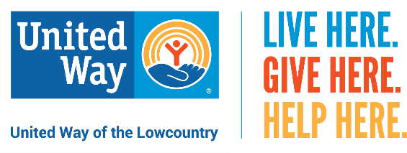

Social Media Posts

Social media is the perfect platform to share that you’re a United Way champion. Below you’ll find posts you can share with your family and friends on Facebook, Instagram, Twitter or Nextdoor.

Best Practices
- Follow us on Facebook at UnitedWayLowcountry
- Tag us in your posts and use the United Way hashtag #LiveUnited or #LiveHereGiveHere to promote the work you are doing to help strengthen the Lowcountry.

- “Share” and “repost” any content directly from our Facebook page. Anything we post is open to you to use.

Social Media Posts

Nonprofits

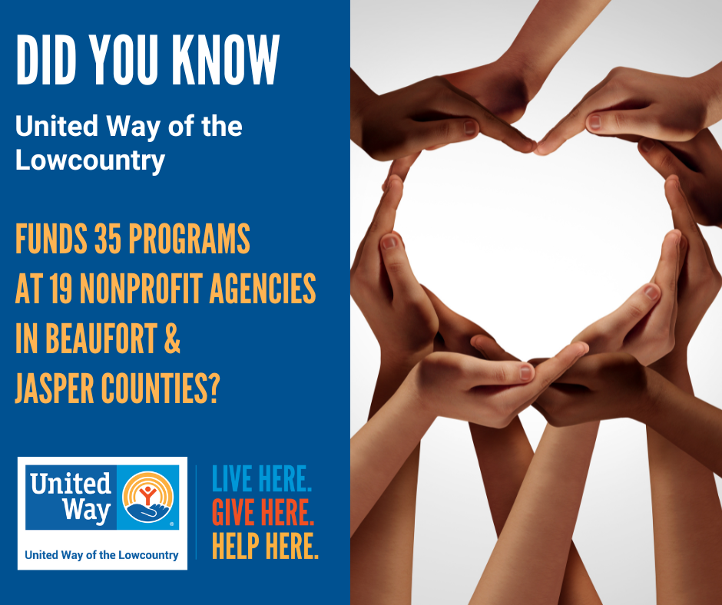

POST COPY – Did you know United Way of the Lowcountry funds 35 programs at 19 nonprofit agencies throughout Beaufort and Jasper counties? You can learn more about United Way’s impact and funding process at https:/www.uwlowcountry.org/community-impact. #LiveUnited #LiveHereGiveHere

Women United and Operation Backpack

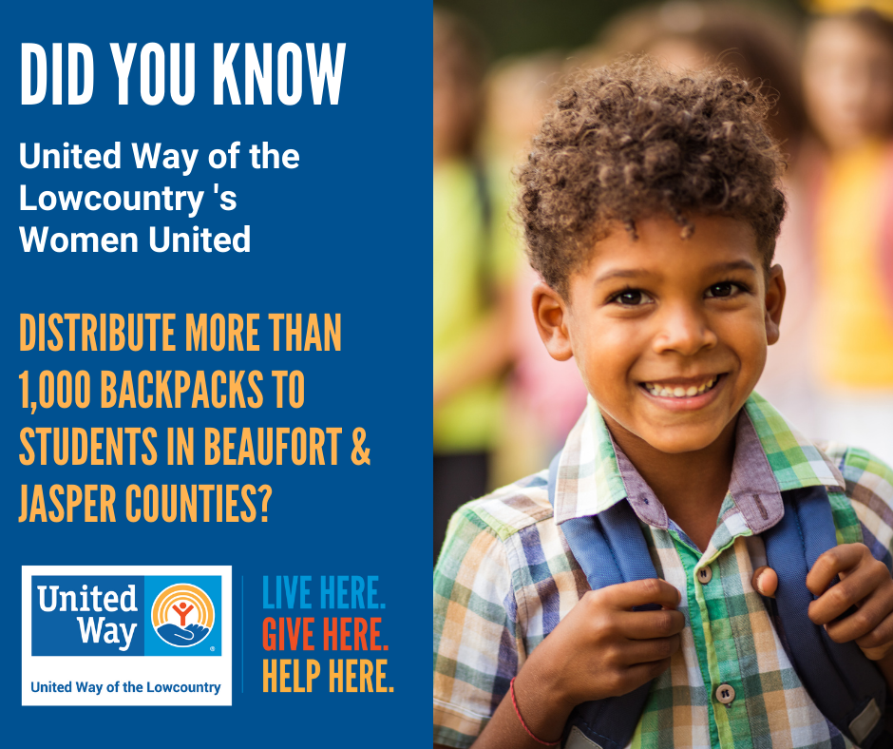

POST COPY – Did you know United Way of the Lowcountry’s Women United distributes more than 1,000 backpacks with school supplies to local children in need in Beaufort and Jasper counties? You can learn more about Women United and Operation Backpack at https:/www.uwlowcountry.org/operation-backpack. #OperationBackpack #LiveUnited #LiveHereGiveHere

HELPLINE

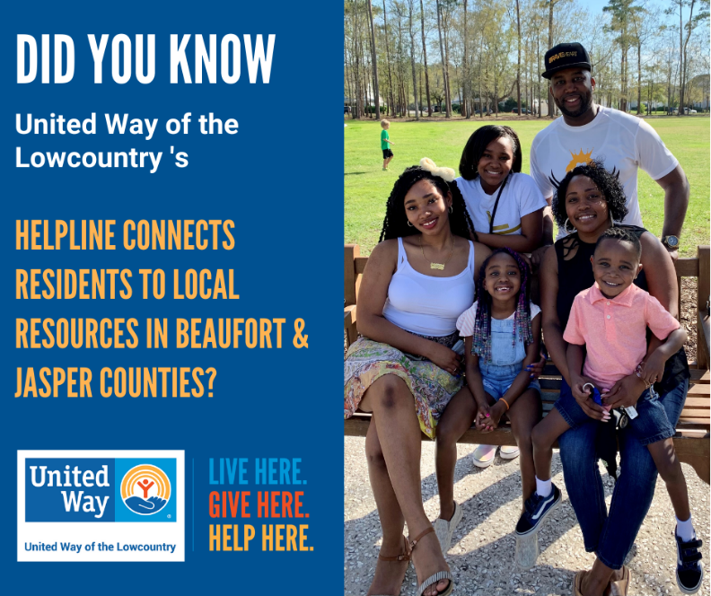

POST COPY – Did you know United Way of the Lowcountry’s HELPLINE serves as a safety net, providing information and referrals to help Beaufort and Jasper county residents find the local resources and services they need? You can learn more about HELPLINE and hear stories from neighbors who received assistance at https:/www.uwlowcountry.org/HELPLINE. #LiveUnited #LiveHereGiveHere

Summer Book Distribution

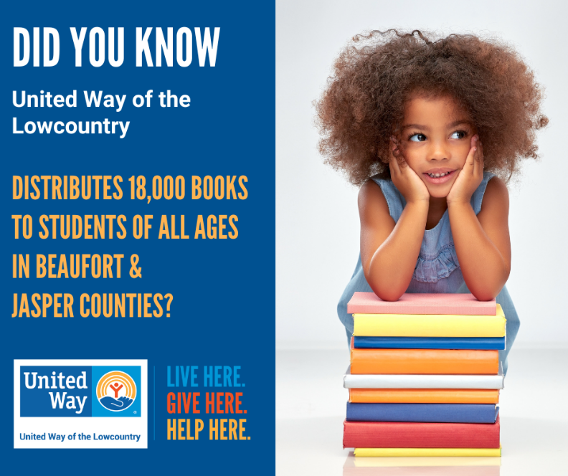

POST COPY – Did you know United Way of the Lowcountry distributes more than 18,000 books each summer to students of all ages in Beaufort and Jasper counties? You can learn more about the importance of summer reading at https:/www.uwlowcountry.org/books. #LiveUnited #LiveHereGiveHere

Early Grade Reading Program and Tutoring Opportunities

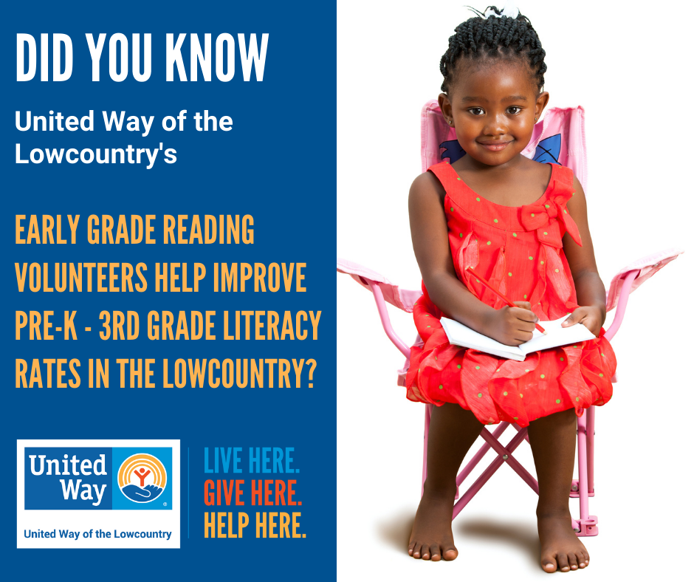
POST COPY – A child learns to read until fourth grade. After that, they read to learn. Did you know United Way of the Lowcountry’s Early Grade Reading volunteer tutors work with Beaufort and Jasper county school districts to improve Pre-K through third grade literacy rates? You can learn more about literacy and tutoring opportunities at https:/www.uwlowcountry.org/read-indeed. #LiveUnited #LiveHereGiveHere

Volunteer Tax Assistance Program

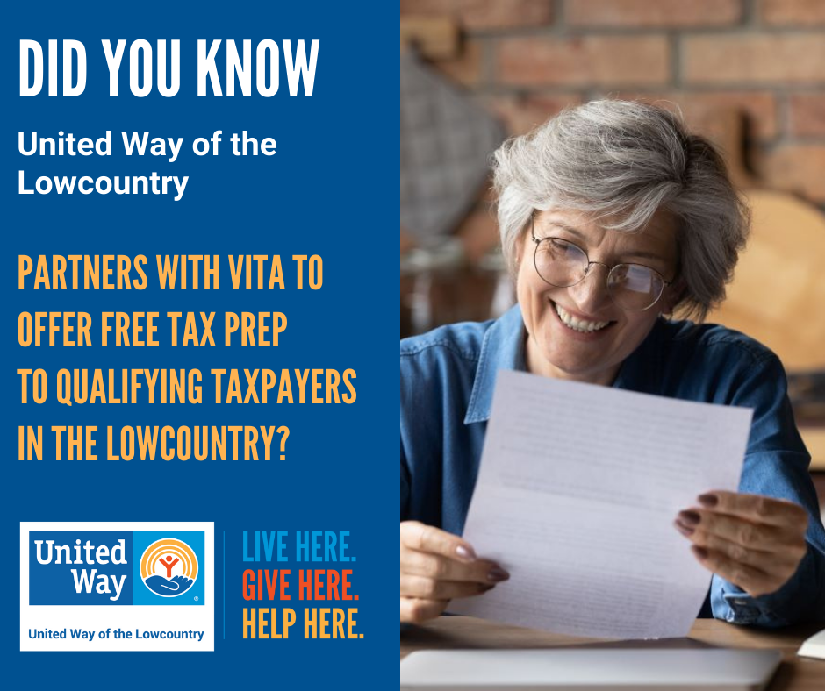

POST COPY – Did you know the Lowcountry Volunteer Income Tax Assistance (VITA) program offers free tax return preparation for qualifying taxpayers in Beaufort and Jasper counties thanks to a partnership between United Way of the Lowcountry, Beaufort County and the IRS? You can learn more about VITA and volunteer opportunities at https:/www.uwlowcountry.org/vita. #VITA #LiveUnited #LiveHereGiveHere

Operation Holiday Heroes

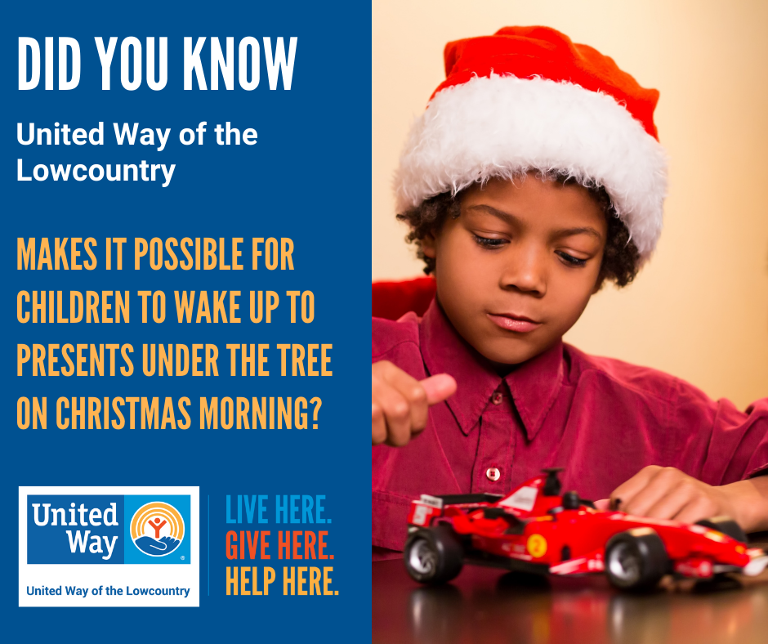

POST COPY – Did you know United Way of the Lowcountry helped make it possible for more than 4,000 children in Beaufort and Jasper counties to wake up to toys under the tree on Christmas morning? You can learn more about Operation Holiday Heroes at https:/www.uwlowcountry.org/holiday-heroes. #OperationHolidayHeroes #LiveUnited #LiveHereGiveHere

