2022 United Way of the Lowcountry Community Champion Kickoff Letter/Email
(Subject Line: Join me/us in making a difference)
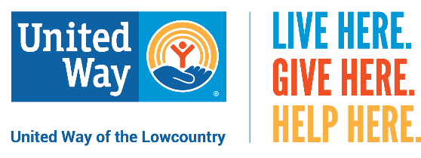
Dear (names),

As you may know, (I am/we are) proud supporters of United Way of the Lowcountry (UWLC), which serves Beaufort and Jasper counties. This past year, 206,673 local people benefited from United Way's Community Impact funded programs and direct services.
These are unprecedented times — the need in our community is greater than it has ever been due to the lingering effects of the pandemic. (I’d/We’d) like to share some information with you about United Way’s excellent work, and we are asking you to consider a generous gift to support this important, well-managed organization.
(I/We) give to the UWLC primarily because there are so many worthy causes that it is impossible to give to them all. We have seen how UWLC's process for determining need, prioritizing those needs and allocating dollars accordingly works, and it gives us great comfort that our donations will be used wisely.
United Way of the Lowcountry has been dedicated to this community for decades, addressing the critical needs of our neighbors and building a stronger community. Below are just a few of the ways UWLC is making an impact:
- 33 programs at local nonprofits throughout Beaufort and Jasper counties. Each program is vetted by community volunteers through site visits as well as financial and program reviews.

- HELPLINE, which serves as a safety net, provided information and referrals to 7,056 community members who had nowhere else to turn.
- Early Grade Reading Initiative, Read Indeed. A child learns to read until fourth grade. After that, they read to learn. With the help of volunteer tutors, our Early Grade Reading Program works with Pre-K through third graders in Beaufort and Jasper counties to help ensure children are prepared for success in school. Last year alone, UWLC distributed more than 18,000 free books to children throughout our community.

(We/I) encourage you to learn more about the impact United Way of the Lowcountry is making in our community, with the information provided. You can also learn more about UWLC and donate directly on their website at www.uwlowcountry.org/donate.

All of us together in (community name) can help make a lasting impact in our community and help our neighbors when they need it the most. Thank you for your consideration and please feel free to contact (me/us) with any questions.

Your Neighbor(s),

Champion Names
Phone Numbers
LIVE HERE. GIVE HERE. HELP HERE.

United Way of the Lowcountry now accepts cryptocurrency. To learn more, visit www.uwlowcountry.org/crypto
If you would like to make a gift of stock, please call 843.982.3040.

