2022 United Way of the Lowcountry Workplace Campaign Email Templates
REMINDER EMAIL #2
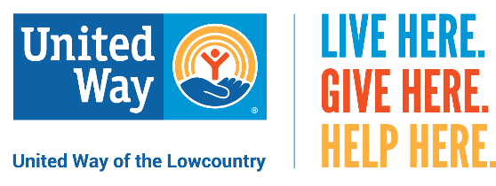
Dear (Company Name) Family,
Did you know that a child learns to read until fourth grade? After that, they read to learn.
Though your support, United Way of the Lowcountry is making an impact on education through its Early Grade Reading Initiatives.
United Way partners directly with Beaufort and Jasper county school districts to ensure students are reading on grade level when they enter 4th grade. A total of 932 students at 13 schools participated in one of three United Way initiatives devoted to improving early childhood literacy:
- Play Partners uses imaginative, play-based activities including music and art to make reading fun for Pre-K students.
- Read to Me offers struggling Kindergarteners group interactive read-alouds.
- Read Indeed helps 1st through 3rd grade students improve their reading comprehension skills by using one on one, in-school volunteer tutors and AmeriCorps members.
Every participating student in United Way’s Pre-K and Kindergarten initiatives receive a collection of books free of charge that they take home to create their own personal library. In fact, during the 2021-2022 school year, more than 18,000 books were distributed to Pre-K and Kindergarten students as well as students attending Jasper County School District’s summer reading camp.
Your investment in UWLC supports LOCAL programs like Read Indeed! that are vital to making Beaufort and Jasper counties a better place to live and work.
I hope you will consider giving to United Way this year by clicking here [insert personalized giving link] to make your online donation by [insert deadline]. It’s the most effective and efficient way to create lasting change in our community. Your gift may be made through payroll deduction, credit card or cash/check. Please remember that every dollar makes an impact.
LIVE HERE. GIVE HERE. HELP HERE.

