Please feel free to use the image of our Annual Campaign thermometer
that is included on the second page of this document.

Dear Friends,
Community is important to me. That is why I'm such a strong supporter of United Way of the Lowcountry. It is, hands down, one of the most effective ways to have a positive impact in our community. With less than 40 days left in its Annual Campaign, United Way needs our help to meet its goal!
United Way is working to strengthen existing programs that help people in need while also looking to find long-term, sustainable solutions to the problems that hold our community back. There will always be a need to stabilize people in crisis, but United Way understands that lives can be transformed when service providers work together and combine resources strategically. When individuals and families in Beaufort and Jasper counties thrive, we become a stronger, more prosperous community.
Please join me in helping United Way of the Lowcountry reach its Annual Campaign goal by March 31, 2023. You can make a secure gift online at www.uwlowcountry.org/donate or mail your gift to PO Box 202, Beaufort, SC 29901.
UNITED, we have the power to create positive change in our community.

Dear Friends,
What makes a community thrive? When all our residents can achieve and maintain self-sufficiency. When the basic needs of food, shelter and utilities are met. When children are reading by 3rd grade and graduating on time. When people have jobs and the knowledge to properly manage their money. That’s what I believe makes the Lowcountry thrive. And that’s why I support United Way of the Lowcountry.
I support United Way of the Lowcountry because I care about this community. With less than 40 days left in its Annual Campaign, United Way needs our help to meet its goal! It’s my hope you will join me in helping United Way of the Lowcountry reach its Annual Campaign goal by March 31, 2023. By making your donation today, you join me in creating a community where children, individuals and families thrive; where neighbors care for each other; and we are proud of all our residents’ quality of life. You can make a secure gift online at www.uwlowcountry.org/donate or mail your gift to PO Box 202, Beaufort, SC 29901.
UNITED, we have the power to create positive change in our community.

Dear Friends,
I believe supporting and being actively involved with United Way of the Lowcountry is one of the best ways to give back to my community. I feel extremely fortunate to be able to live in and work in such a beautiful area, and I want to do my part to help others who need a hand up.

UNITED, our support improves lives. Whether you live in Beaufort, Bluffton, Hardeeville, Hilton Head Island, Ridgeland, or somewhere in between, your donation stays local. United Way of the Lowcountry improves lives in part through a rigorous community investment process that invests your generosity in 35 effective programs at more than 20 local nonprofits as well as in collaborations and initiatives that are improving education, financial mobility, health and basic needs in Beaufort and Jasper counties. The process is transparent, volunteer-driven, and ensures that every dollar donated is spent wisely where it is needed most.
With less than 40 days left in its Annual Campaign, United Way needs our help to meet its goal! Please join me in helping United Way of the Lowcountry reach its Annual Campaign goal by March 31, 2023. You can make a secure gift online at www.uwlowcountry.org/donate or mail your gift to PO Box 202, Beaufort, SC 29901.
UNITED, we have the power to create positive change in our community.

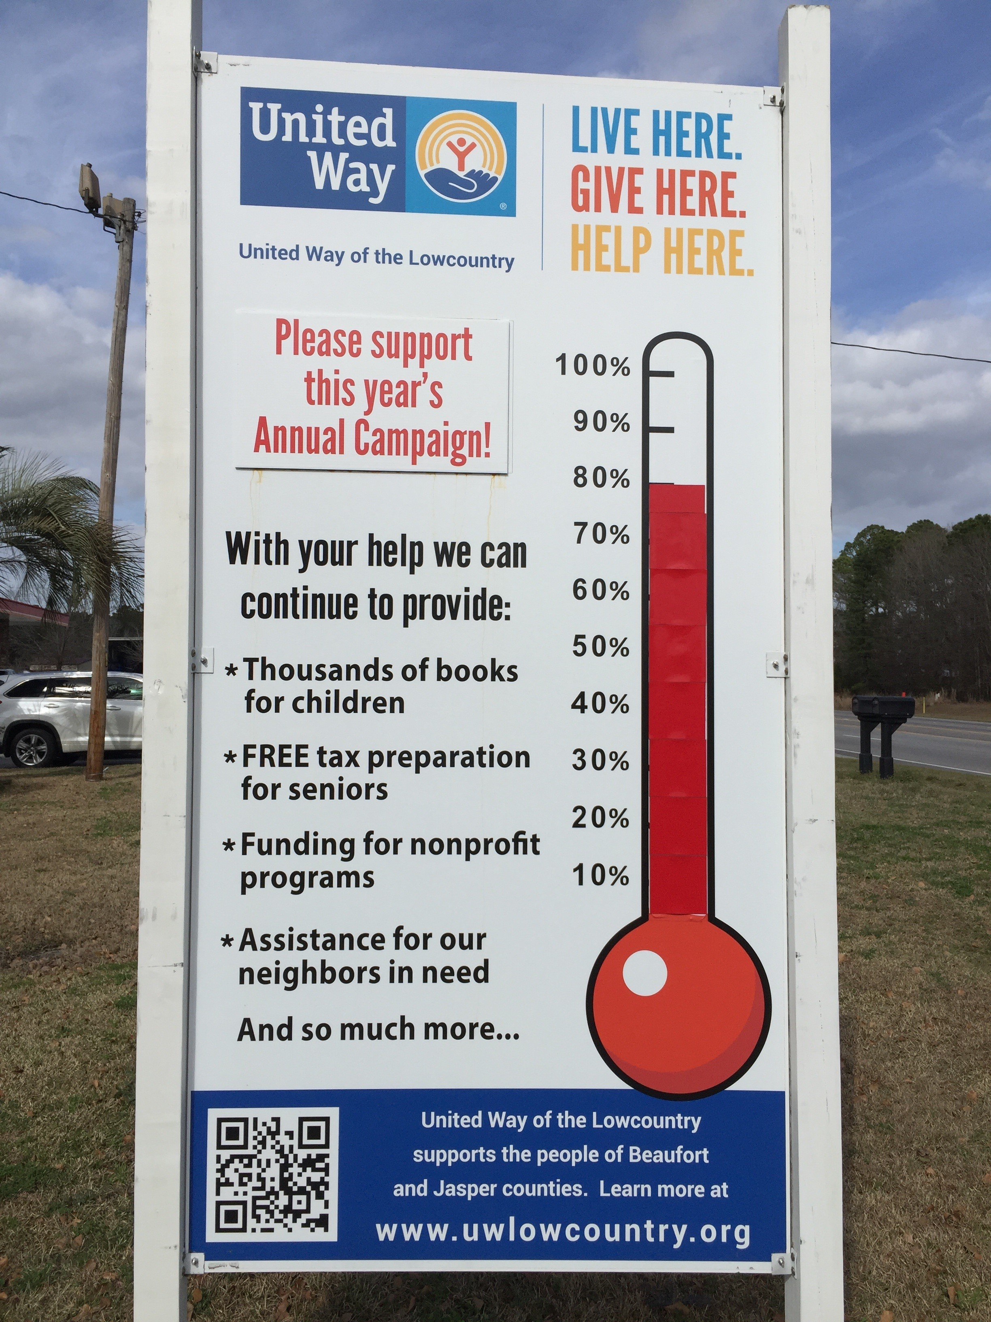

Please feel free to reach out to Wendy Jones at wjones@uwlowcountry.org or 843.379.3065 if you have any questions.

